**NGS DATA QUALITY CHECK FOR HER2 GENE**

1. SRA accession number:  SRX20303034
2. NGS platform and layout:
   * 1. NGS platform : GENOMIC
     2. NGS Layout : PAIRED
3. Basic statistics: (insert image with summary)

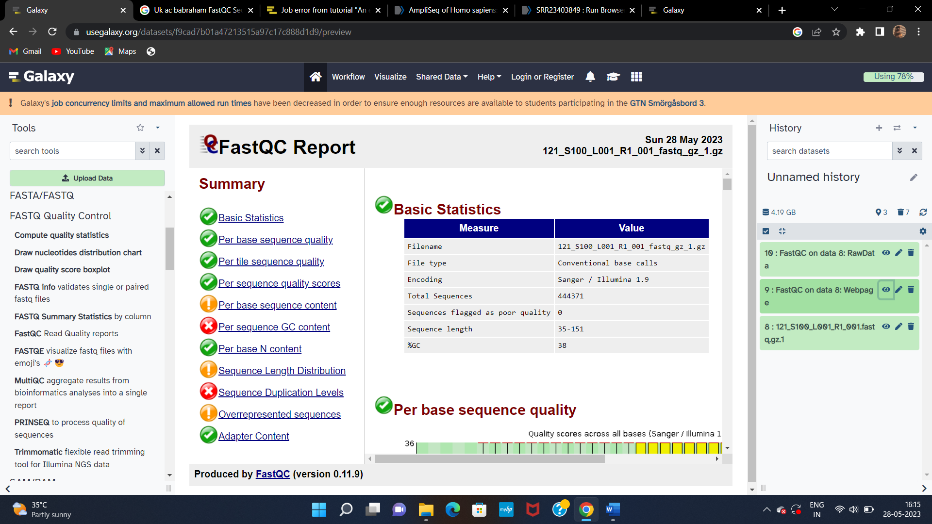

Summary :  The basic statistics for the sample provides information on the total number of reads sequenced for each sample and helps to make sure the read length and %GC content is as expected. The sequence length ranges from 35-151 and the %GC content is 38. The encoding is carried out by illumina sequencing.

1. Per Base sequence quality: (insert image with summary)



Summary : This plot provides the distribution of quality scores at each position in the read across all reads. Based on this plot, the quality scores for the beginning nucleotides are high, with nearly all reads having scores above 28. The quality scores appear to drop going from the beginning toward the end of the reads. Per base quality sequency is interpreted as a green flag.

1. Per sequence quality score: (insert image with summary)

Summary : This plot gives the average quality score on the x-axis and the number of sequences with that average on the y-axis. The plot shows a good average quality per read. The mean quality must be above 20.